1. 
2. As Class Diagram is used to represent structure of classes but what if you want to include some details about those classes.

In other words, what if there’s someone that we want to point out to someone reading our diagrams?

1. This is where “Notes” comes into picture used to add additional info to class diagrams and we can use them on other types of UML diagrams.
2. Notes are essentially free-text fields, and you can include anything that you want in them - from general information on the diagram, to snippets of code, or anything in b/w.
3. If you try to include too much info, your notes can end up cluttering the diagram and making it harder to understand.  
   However, if you use them properly notes can be an incredibly **valuable additional** to your UML diagrams.
4. Keep in mind that notes simply provide information on your diagrams - there are no rules that say the contents of your notes must reflect your code.  
   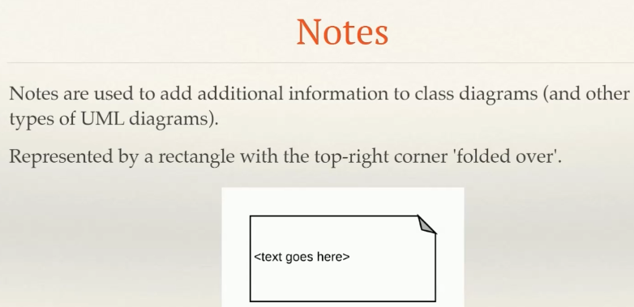
5. **How to represent “Notes”**?
   1. By Rectangle with the top-right convert “folded over” much like a piece of paper.
6. We can use notes in two ways.